

Admissions Policy and Procedures 2027-28

|  |  |
| --- | --- |
| Agreed with Support Staff Trade Unions | **n/a** |
| Adopted by the Governing Body |  |
| Next Review Due |  |
| Agreed with Teacher Trade Unions and Professional Associations | **n/a** |

**Welland Park Academy - Proposed Admissions Policy for entry from September 2026**

The admission authority for Welland Park Academy is the “Welland Park Academy - Academy Trust”. Welland Park Academy Trust is also responsible for arranging an independent appeal against refusal of a place at the school. The Trust must act in accordance with admissions legislation and the School Admissions Code.

**Purpose of this Policy**  
The purpose of the Policy is to ensure that places at Welland Park Academy are allocated and offered in an open and fair way.

**Applying for a place**  
A parent can apply for a place for their child at any state-funded school. Parents apply to the local authority in which they live (for Welland Park Academy this is usually Leicestershire County Council) for a place at Welland Park Academy. The annual closing date for applications to be made to the local authority is **31st October** for a place the following September.

**Students with Education Health and Care Plans (EHCP)**

Any student who has an EHCP will fall outside of this Admission Policy and the statutory framework that is relevant to their circumstances will be applied. Queries about placement for EHCP students must be made to the Local Authority who issued the Plan.

**The Admissions Timeline – Academic Year before Admission**

* 31st October Closing date for applications to the Local Authority
* 31st January Final date for late applications to be considered ’on time’
* 28th February Publication of appeals timeline on website
* 1st March (or next working day) National Offer day for secondary school places
* April to June Appeals process and outcomes
* August/ September New intake starts secondary school

**Planned admission number (PAN)**  
Welland Park Academy will have an admission number of 210 for entry into year 7.

If Welland Park Academy is undersubscribed, any parent that applies will be offered a place. If oversubscribed, it will rank applications in order against its published oversubscription criteria below and return that list to the local authority.

**Late Applications**

Any applications received after the closing date of 31st October will be accepted but considered only after those received by the closing date.

All applications received by the relevant closing date will be considered first. Where there are more applications than places, these will be ordered in accordance with the approved oversubscription criteria set out below.

All late applications received after the 31st of October will be considered after those that have been received on-time. If an application is late due to exceptional circumstances a request can be made to the Academy to take those circumstances into account. It is for the applicant to provide documentary evidence of the reason for lateness this must be with the Academy no later than no later than 31st January in the Admission Year. This will be reviewed, and written reasons will be provided for any decision.

It is the legal responsibility for the Local Authority where the child resides to co-ordinate this process for Year 7 admissions.

**Decisions**

All decisions about admissions will be made using this policy and relevant oversubscription criteria for Welland Park Academy.

All offers for normal admission round Year 7 places will be made on National Offer Day 1st March, or the next working day by the home Local Authority.

All offers for in-year places will be made within 15 days.

**Oversubscription criteria**  
Where there are more applications for Welland Park Academy than there are places available and, after the admission of children with an education, health and care plan (EHCP) where Welland Park Academy is named in the plan, the following criteria (in the order listed) will be used to allocate places:

1. A 'looked after child' or a child who was previously looked after, including those children who appear (to the admission authority) to have been in state care outside of England and ceased to be in state care as a result of being adopted. A looked after child is a child who is (a) in the care of a local authority, or (b) being provided with accommodation by a local authority in the exercise of their social services functions (see the definition in section 22(1) of the Children Act 1989). Previously looked after children are children who were looked after but ceased to be so because they were adopted (or became subject to a child arrangements order or special guardianship order).

2. Children who live in Welland Park Academy catchment area for the majority of the school week, with priority for admission given to those children who live nearest to Welland Park Academy as the crow flies. This Catchment area is available on the school website and

a copy is also attached to this document. A larger copy of the catchment area map is available from the school office. Welland Park Academy catchment area is the sum of the catchment areas of the feeder schools listed in criteria 4.

3. Children who have a brother or sister attending Welland Park Academy at the time of application, with priority for admission given to those children who live nearest to Welland Park Academy as the crow files. For these arrangements the term brother or sister includes half brother or sister or legally adopted child being regarded as the brother or sister.

4. Children who have a serious medical condition or exceptional social or domestic needs that make it essential they attend the school requested. (Professional documentation confirming the situation must be submitted with the application.)

5. Children currently attending a catchment feeder primary school, with priority for admission given to those children who live nearest to Welland Park Academy as the crow files.

Catchment feeder schools are:

**Little Bowden, Farndon Fields, St Joseph’s, Lubenham, Great Bowden, Ridgeway, Meadowdale, Foxton, Church Langton, Market Harborough Church of England, Billesdon and Husbands Bosworth.**

6. Other children, with priority for admission given to children who live nearest to Welland Park Academy as the crow flies.

**Notes:**  
Where any priority due to distance is applied, it will be measured in a straight line or “as the crow flies” from the point that the child’s home meets the public highway to the school’s main designated front pedestrian gate. This will be measured using a computerised mapping system.

Where two or more children receive equal admission priority given the above criteria, random allocation will be used as a tie-break in any criterion to decide who has highest priority for admission. This process will be independently verified.

Welland Park Academy may need to ask for further information or documentation when applying the oversubscription criteria, this may include, but is not limited to:

* Address / residency
* Child’s date of birth
* A copy of an adoption order, residence order or special guardianship order and a letter from the local authority that last looked after the child confirming that he or she was looked after immediately prior to that order being made.

All preferences are collated and prioritised in line with the oversubscription criteria. Parents then receive an offer from the local authority at the highest preference school at which a place is available on **1st March** or the first working day thereafter in the year in which the child will be admitted.

**Right to appeal**  
Parents have the right to appeal against Welland Park Academy’s decision to refuse admission.

When Welland Park Academy (or the Local Authority in their coordination role) informs a parent of a decision to refuse their child a place at the school, it will include:

* The reason why admission was refused.
* Information about the right to appeal.
* The contact details for making an appeal.

Parents will be informed that, if they wish to appeal, they must set out their grounds for appeal in writing.

Welland Park Academy will establish an independent appeals panel to hear the appeal. The panel will decide whether to uphold or dismiss the appeal. Where a panel upholds the appeal Welland Park Academy is required to admit the child.

**Withdrawing an offer or a place**  
Welland Park Academy will withdraw an offer if:

* It is established that the offer was obtained through a fraudulent or intentionally misleading application.
* A parent has not responded within a reasonable period of time to the offer of a place (14 calendar days). During this 14-day period the parent will be notified that the offer may be withdrawn and given an opportunity to respond and explain.
* It has been offered in error.

Welland Park Academy will not withdraw a place once a child has started at Welland Park Academy, except where that place was fraudulently obtained.

**Waiting list**  
If Welland Park Academy is oversubscribed, it will maintain a clear, fair and objective waiting list. Priority will continue to be based upon the oversubscription criteria. The waiting list will be maintained for the first academic term in the year of admission.

**In-year applications**  
Welland Park Academy is responsible for administering in-year applications. A parent requesting a place at the school should request an application form from the school office. On receipt of an in-year application the school will:

* Allocate a place if one is available.
* If a place is not available, inform parents of that fact and the reasons why and inform parents of their right to appeal against the refusal of a place.

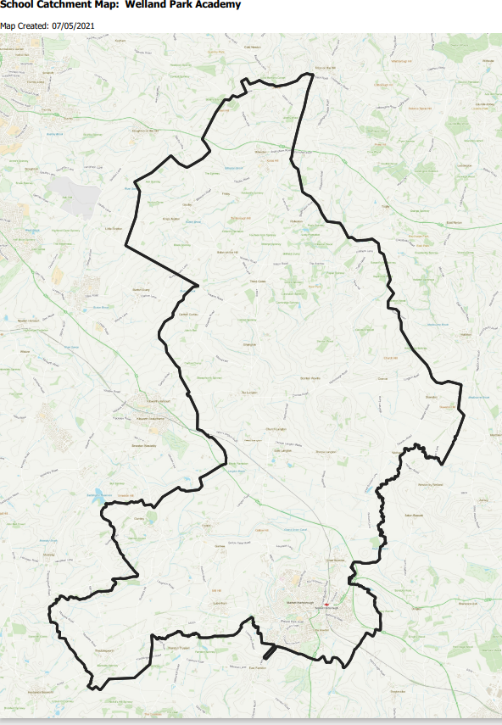**“Welland Park Academy” catchment area**