Extra Curricular Club- System Guide
How to sign in
Google SOCS and select the first option:
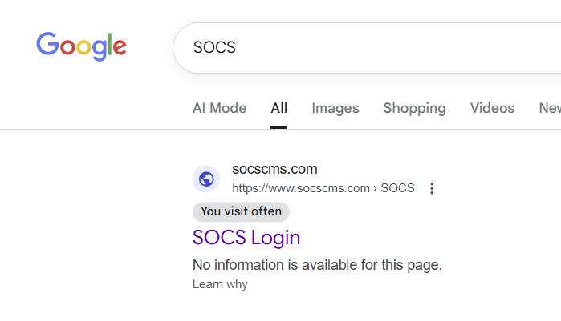
Next select ‘student’ login
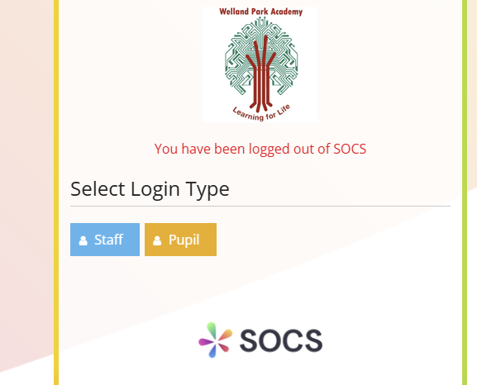
If you are already logged in to your school emails, you will be logged in automatically. If not, you will need to enter your school email address and password.
How to see what clubs are on offer
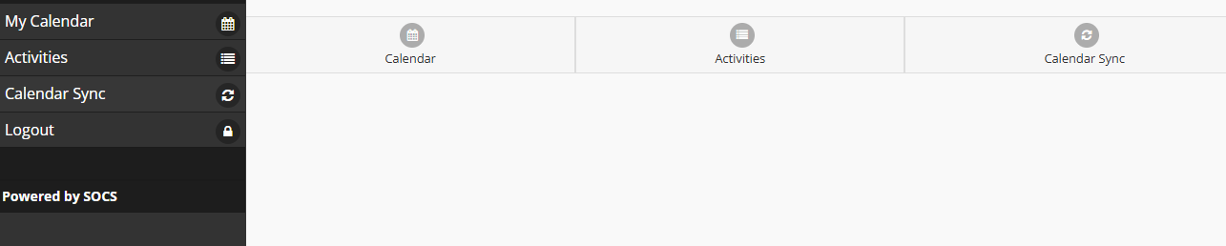
Select ‘activities’ on the main icon menu:

Select type of activity you want to view:

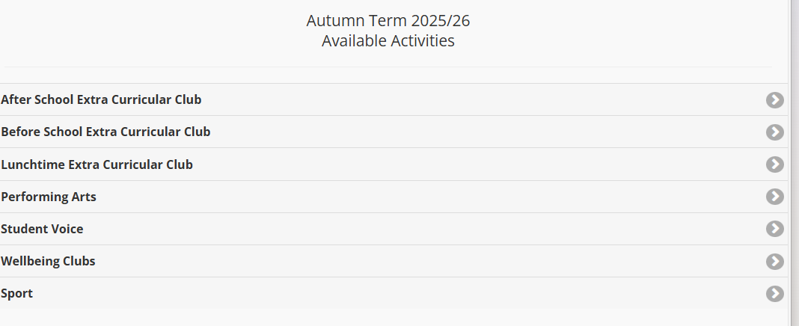

Click view events to see when and where the club is taking place:
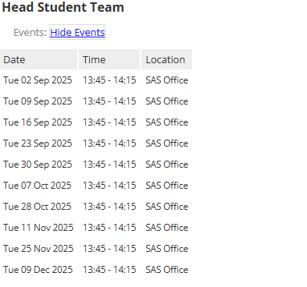

Click Add if you want to attend that event
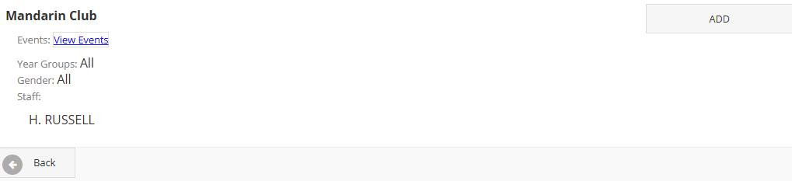

If the event is ‘invite only’ a teacher will need to invite you.

