Pupil premium strategy statement for Welland Park Academy 2025 – 2026

This statement details our school’s use of pupil premium funding to help improve the attainment of our disadvantaged pupils.

It outlines our pupil premium strategy, how we intend to spend the funding in this academic year and the effect that last year’s spending of pupil premium had within our school.

School overview

Detail | Data
Welland Park Academy
Number of pupils in school | 1015
Proportion (%) of pupil premium eligible pupils | (156) 15.38%
Academic year/years that our current pupil premium strategy plan covers (3 year plans are recommended) | 2024 - 2027 overall but  (2025 – 2026) for this specific statement.
Date this statement was published | 19th December 2025
Date on which it will be reviewed | November 2026
Statement authorised by | Pete Leatherland
Pupil premium lead | Danielle Pendell
Governor / Trustee lead | Claire Parry/Simone Harrison

Funding overview

Detail | Amount
Pupil premium funding allocation this academic year | £135,450
Pupil premium funding carried forward from previous years (enter £0 if not applicable) | £0
Total budget for this academic year | £135,450

Part A: Pupil premium strategy plan

Statement of intent
Welland Park Academy is dedicated to helping every student achieve their full potential while narrowing the attainment and progress gap between disadvantaged students and their peers. This strategy values evidence-based research in identifying the most effective activities and interventions, particularly those that focus on delivering the highest quality teaching.
Our approach is rooted in educating the whole child, ensuring that as many barriers as possible are removed. This enables students to fully engage with their education and thrive in their learning environment.
The plan seeks to address challenges faced by disadvantaged students by implementing a three-tiered approach, aligned with guidance from the Department for Education (DfE) and the Education Endowment Foundation (EEF). We aim to embed strategies at every level to improve the educational outcomes and wellbeing of disadvantaged students.
The intent of our strategy plan is to work with our disadvantaged students to ensure that they access the curriculum and all opportunities to realise their full potential. Ensuring parity of outcomes for all educational groups is a key part of our school development plan.
We have a track record of strong outcomes for both our disadvantaged and non-disadvantaged cohort; however, there remains a distance between these measures. In order to sustain the attainment performance of those students not deemed to be disadvantaged, whilst improving progress for our disadvantaged students, we must make the best use of teaching and learning strategies which have a strong and sustainable impact on those students most in need.
We aim to make our Academy a fully inclusive one that promotes a sense of community and belonging for all students.

Challenges
This details the key challenges to achievement that we have identified among our disadvantaged pupils.

Challenge number | Detail of challenge
1 | Attainment  There is still a gap between disadvantaged and non – disadvantaged students in latest exam series. Progress has been historically strong (similar to national figures for non-disadvantaged students) but there is an A8 gap of 10 between disadvantaged and non-disadvantaged peers within the Academy, however this has narrowed. The gap between our disadvantaged peers and national non disadvantage has also widened slightly (non-significantly) for students gaining a 5+ in both English and Maths, however, the Eng. and Math’s 4+ gap has narrowed, by nearly 3%.
2 | Attendance  Post-Covid, as nationally, attendance has dipped and we strive to ensure high attendance of all. PP remains a key focus for the academy as it is consistently below the school average of 94.53%, at 89.9% for 2024/25. The PP cohort that was PA for the same period was 24.83%, and PA for non-PP students stands was 11.97%.  This difference highlights the need for targeted interventions to support PP students in improving their attendance rates.
3 | Lower literacy levels/Reading  Reading ages – 26% of PP students in year 7-9 have a standardised reading score of below 85 sometimes significantly below chronological age upon entry to the Academy. This impacts understanding and/or processing and the ability to read educational literature such as worksheets, text books, support materials and exam papers.
4 | Increase in SEND  SEND needs have steadily increased, we have an above average percentage of students with SEND which is above the national average and a higher-than-average percentage of EHCP students, many who are also PP (26% are both PP and SEND).  Co-occurring high SEND need, particularly for those with the SEMH area of need which is significantly above the national average.
5 | Well-being/Mental health  Significantly more social and emotional difficulties. We have observed the significant increase in the support required for mental health, self-harm and eating disorders, (this is disproportionate to PP and includes poverty, parents seeking more financial assistance, both within Market Harborough and the economically disadvantaged surrounding areas of Rothwell and Desborough, from which an increasing proportion of our students come from). Additionally there has been a notable rise in students exhibiting emotion-based school avoidance, a trend that underscores an urgent need to provide enhanced support for students facing challenges related to anxiety. This is evident in the incidents being addressed, and referrals being made, by the pastoral support team, however there is a large gap in what services are able to provide in a timely manner. Development of resilience and growth mindset are vital to enable our young people to face the challenges ahead in their education and lives and it is vital to address these issues to create a supportive educational environment for all students.
6 | Post 16  Working to ensure we have no NEETs annually (Not in education, employment or training) post 16. Because of the high SEND levels and increasing disadvantage, there is a risk of NEET when they leave WPA. This year we are aware of two students, both PP that were NEET. This means ensuring that more students complete work experience in year 10 to ensure they are prepared for the next stage of their academic journey. This year 16/26 (current year 11s), 62% of PP students completed work experience. Our assessment is that PP students struggle to source their own placements and need help, both financial and practical with sourcing this.

Intended outcomes
This explains the outcomes we are aiming for by the end of our current strategy plan, and how we will measure whether they have been achieved.

Intended outcome | Success criteria
The academy will maintain / increase the successful progress and attainment outcomes in our exam years whilst ensuring there is little or no variation between key learner groups in our year groups. | - Continue the trend of narrowing the gap and ensure disadvantaged are in line with national average for non-disadvantaged or better – A8 currently -10 (40.3 compared to 50.3 WPA disadvantaged compared to national non-disadvantaged)  - Gap between WPA disadvantaged and non disadvantage 5+ in both English and Maths to narrow, from a 27% difference to 20% by raising the attainment of disadvantaged learners.
Excellent attendance of Disadvantaged and SEND students which supports their learning and ensures they can access the required support and protective factors. | - The attendance for disadvantaged students to increase to over 92% (currently 89.9% 2024/25) and PA to reduce to below 20% (currently 24.83% 2024/25)  - Continue to monitor and develop our attendance strategies to maintain and improve this further  - Breakfast club is well attended by PP cohort with over 50% attending
Improvement in literacy/reading skills by improving vocabulary. | - Hachette tests for literacy and numeracy for all KS3, earlier identification and interventions  - Reading ages in line with or exceed chronological age for all PP pupils
Staff continue to deliver HQFT (and therefore aspirations of PP) through targeted, high quality CPD linked to appraisal/Strategic plan where possible. | - Whole school monitoring of teaching quality to inform CPD planning (e.g. lesson observations, learning walks, progress analysis etc)  - Identification of universal and targeted strategies to meet the individual learning needs
The academy is inclusive, where students have a strong sense of belonging and have a strong identity with school and participate in activities in addition to the curriculum to represent the school or enhance their own knowledge / learning. | - We plan participation in wider activities including trips and visits for each PP student  - Tracking of PP engagement is effective through SOCS  - PP students targeted for extracurricular, accelerating the development of cultural capital through enrichment activities across the curriculum. To improve on last year’s figures  - Attendance and commitment scores will increase as well as increasing aspirations of PP pupils  - Creation of an inclusive school culture and strong community involvement to foster a sense of belonging among vulnerable learners  - The school adopts a belongingness-centered definition of inclusion, emphasizing students' subjective sense of belonging and safety within the school community as evidenced by student voice
Students will have the skills, resilience and support to manage their mental health and well-being. | - 100% of students needing counselling / referrals have access to those  - At least 90% of targeted students attend Bloom, Flourish, Mind sessions and Teen Health workshops  - 100% of identified students receive scheduled 1:1 check-ins with a Mental Health First Aider  - Student voice data shows an increase in confidence; a reduction in concerns and an increase in the ability to address concerns at an early stage  - Positive feedback from students and parents in well-being surveys (target: 85% agree or strongly agree that support is effective)  - Improved attendance and engagement for students previously flagged for mental health concerns
Targeted interventions to meet the specific needs of disadvantaged students with SEND. | - Standardized assessments for all KS3 to be completed within the first month of school  - Early targeted interventions  - Attendance and attainment for the PP/SEND cohorts rises as shown by increases in 4/5+ in both English and Maths and A8 (to be above national)
Students have the awareness, life skills, knowledge and achievements to enable them to access and succeed in the next stage of their education / life. Improved aspirations of disadvantaged students. | - Students select options that allow them to be successful. They transition successfully into Years 7 and 10  - Students in KS4 are ready for the next stage and are moving on to appropriate, high-quality destinations  - 100% of students successfully maintain their place in post-16 training / education and NEET is zero  - All Gatsby benchmarks are met and high-quality advice and guidance is given  - Improved attendance, behaviour, engagement in lessons & extra-curricular activities, student voice is positive  - All PP students complete an interview with the resident Careers Advisor, 2 formal practice interviews and opportunity to attend the biannual Careers Fair and mini careers fair to support post 16 applications  - Work Experience is fully funded for disadvantaged students and participation rate increases to 80% (currently 62%)

Activity in this academic year
This details how we intend to spend our pupil premium (and recovery premium funding)
this academic year to address the challenges listed above.

Teaching (for example, CPD, recruitment and retention)
Budgeted cost: £85,518.00

Activity | Evidence that supports this approach  All activities are linked to the EEF document “The EEF Guide to supporting School Planning: A tiered approach to 2021”. Further specific references are shown in one of the two ways below:  EEF toolkit references  EEF guidance report references  Other research/evidence | Challenge number(s) addressed
Accurate identification of base line levels and reading ages to support literacy work, Hachette testing for KS3 | - EEF – Diagnostic Assessment  - EEF - Gathering and interpreting data to identify priorities | 1, 2, 3, and 6
Funding of smaller class sizes in CORE subjects lower sets with a commitment to ensuring specialized subject specific teachers | - PP students are over-represented in the lower CORE sets  - The effect sizes found by Hattie (2012) for Providing formative evaluation (rank 4), Micro-teaching (rank 6), Feedback (rank 10) and Teacher-student relationships (rank 12) can all be delivered more effectively to PP students in smaller groups.  - EEF Teaching and Learning Toolkit +1 month, low impact for high cost  - A Department for Education report on specialist vs non-specialist teaching in England found high prevalence of specialist teaching, but mixed or limited direct associations with attainment once other factors were controlled—suggesting that specialism matters most when coupled with strong pedagogy and curriculum | 1,3 and 4
CPD program focusing on cold calling, explicit instruction, metacognition, retrieval, spaced learning, marking and feedback – part of HQFT. | - Hattie - Meta-cognitive strategies Effect Size 0.60, high impact  - EEF - Teaching and Learning Toolkit Feedback +6 months, high impact for low cost  - EEF - Teaching and Learning Toolkit Metacognition and self-regulation +8 months, high impact for low cost  - Hattie – Scaffolding ES 0.82, very high impact  - DfE ‘Delivering World Class Teachers’  - ‘Good teaching is the most important lever schools have to improve outcomes for disadvantaged pupils’ EEF  - EEF – Effective professional Development | 1 and 3
Structured reading interventions with small groups and whole class  - School-wide focus on literacy reading and vocabulary, supported by the literacy lead and targeted CPD  - Use of Reading Wise in year 7  - Guided reading sessions in year 8 | - EEF – Teaching and Learning Toolkit, Reading comprehension strategies +7 months, high impact for very low cost  - EEF – Teaching and Learning Toolkit, Small group interventions +4 months moderate impact for low cost  - Hattie - Repeated reading programs ES 0.75, high impact  - EEF - Oral language interventions +6 months, high impact for very low cost | 1, 2, 3 and 6

- Hattie’s work on impact of interventions

Targeted academic support (for example, tutoring, one-to-one support structured interventions)
Budgeted cost: £20,812.00

Activity | Evidence that supports this approach | Challenge number(s) addressed
Maths specialist to support PP students | - EEF - Teaching and Learning Toolkit, Small group interventions +4 months moderate impact for low cost  - EEF - Making a Difference with Effective Tutoring | 1 and 2
Boost - GCSE academic intervention | - Hattie Visible Learning (rank 3) | 1, 3 and 6
Strategies for inclusive practise and interventions to address need; Including Lexonic, Inference Literacy, Prodigy numeracy and Readingwise decoding. Specific social and emotional interventions to support the largest area of need, SEMH. | - EEF – Teaching and Learning Toolkit, Individualised instruction +4 months, moderate impact for low cost  - EEF – Teaching and Learning Toolkit, TA interventions +4 months, moderate impact for moderate cost  EEF – effective professional Development  EEF – Special Educational Needs in Mainstream School | 1, 3, and 4
ADT Contribution, PP pupils are provided with the basic equipment for these lessons | EEF – Access to technology and curricula materials | 1, 2 and 6
Other targeted interventions including music lessons, alternative provision education, tuition outside of school, uniform, transport, extra curricula and school trips. For example Duke of Edinburgh Award, cultural capital trips | - EEF - Participation in the Arts +3 months  - EEF - School trips engender a feeling of collegiality and friendship and improve wellbeing and have the same impact as Summer schools +3 months | 4,6, and 7
Raising Achievement Plan meetings with Vice Principal for outcomes, core subject leads, HOY 11, Pastoral support for Manager Y11, SENDCo and PP coordinator | EEF - Gathering and interpreting data to identify priorities | 1 and 3
Further maths interventions through organising support packs/resources for SEND and PP students,  printing of Knowledge Organisers upon completion and an alternative way of setting Year 7 students so that they are placed in broader ability bands rather than strict sets | EEF – Diagnostic Assessment  EEF - Gathering and interpreting data to identify priorities | 1, 2, 5 and 6

Wider strategies (for example, related to attendance, behaviour, wellbeing)
Budgeted cost: £29,126.00

Activity | Evidence that supports this approach | Challenge number(s) addressed
Use of free breakfast club to encourage attendance to school, with a meet and greet by key staff. | - EEF ‘magic breakfast’ – 2+ months  - EEF – Breakfast club: Rapid evidence assessment (August 2004) | 1, 2 and 4
Summer school for Year 6 students | - EEF Teaching and Learning Toolkit, Summer Schools + 3 months, moderate impact for moderate cost | 1, 2, 3, 4 and 5
Supporting attendance  Student Support Mentor targeted attendance tracking and support | - ‘The link between attendance and achievement is clearly established’ DfE Research 2016  - EEF Teaching and Learning Toolkit, Social and emotional learning +3 months, moderate impact for very low cost | 1 and 2
Mentor programme with a member of staff for all year 11 PP students, academic, careers, post 16 and pastoral issues including tracking and understanding of ACES/PCES. Rolled out to Y7 and year 10.  Circle time with PP coordinator. | - Hattie – Mentoring ES 0.12  - EEF Teaching and Learning Toolkit, +2 months, low impact for moderate cost | 1, 2, 3, 4,5 and 6
Funding for enrichment activities | - EEF - Physical Activity +1 month  - EEF - Arts participation +3 months | 1, 2, 3,4 and 6
Supporting students’ social, emotional and behavioural needs.  Enhanced pastoral support for well-being through RABG, ELSA, Counsellor, emotional and self-esteem workshops including, Bloom, Flourish, Mind, Well-being drop in for KS3 and KS4, Cube, Teen Health and Relate (Relationships Centre) | - EEF – Teaching and Learning Toolkit, Social and emotional learning +3 months  - EEF - Teaching and Learning Toolkit, Mentoring +2 months  - EEF - Teaching and Learning Toolkit, Behaviour interventions +3 months | 1,2,3,4,5 and 6
Support with hygiene products, stationery, uniform | Funding recommendations adapted from the National Food Strategy | 1, 2 and 5
Use of SLT to ensure parental contact / engagement with all parents of PP that have not attended parents evenings | - EEF – Teaching and Learning Toolkit, Parental engagement +4 months | 1, 2 and 6
Use of incentives e.g. termly celebration assemblies, attendance rewards, awards at Presentation Evening | - EEF – Behaviour interventions +3 months | 1 and 2
All departments offer an additional club/trip or extra curricular activity, specifically aimed at disadvantaged students, for example; Healthy breakfast making for year 7s, Space Centre trip and stargazing sleepover and library visit. | - EEF highlights that enrichment activities (including trips, arts, and cultural experiences) can improve motivation, engagement, and academic outcomes, especially when linked to curriculum learning.  - Studies show that exposure to museums, theatre, and historical sites enhances vocabulary, background knowledge, and critical thinking—key drivers of attainment in subjects like English and humanities.  - Social mobility research (Sutton Trust) finds that disadvantaged pupils often lack access to experiences that broaden horizons, which can affect university aspirations and career choices.
Supporting PP students in paying for work experience placements, careers meeting with career advisor, post 16 support, exposure to local labour market and apprenticeships and post 16 providers through a careers fair and interviews with external in year 9 and 11 | - Disadvantaged students can be as much as twice as likely to become NEET (DfE report, 2015).  - EEF Careers education infographic | 6

Total budgeted cost: £ 135,456

Part B: Review of outcomes in the previous academic year

Pupil premium strategy outcomes
This details the impact that our pupil premium activity had on pupils in the 2024 to 2025 academic year.
 | Full Cohort | Disadvantaged Cohort
No. of pupils | 181 | 31
A8 score | 53.2 | 40.3
English & maths at grade 5+ | 65.7% | 38.7%
English & maths at grade 4+ | 80.1% | 54.8%
In education, apprenticeships or employed for 2 terms after KS4 (2023 school leavers) | 92% | 73%
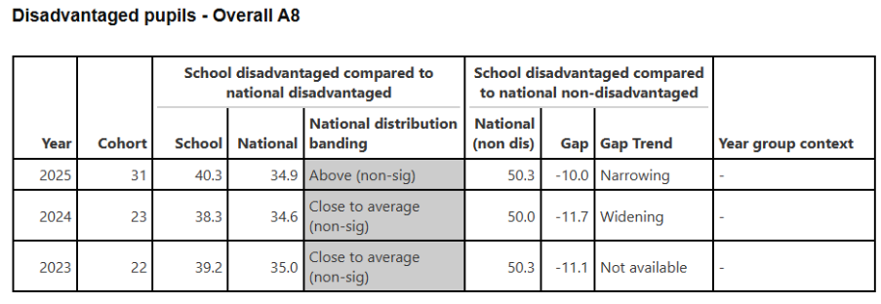
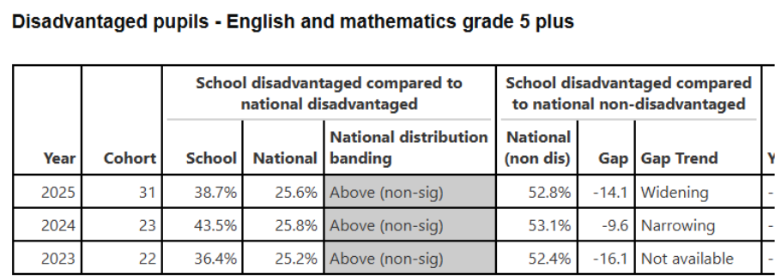
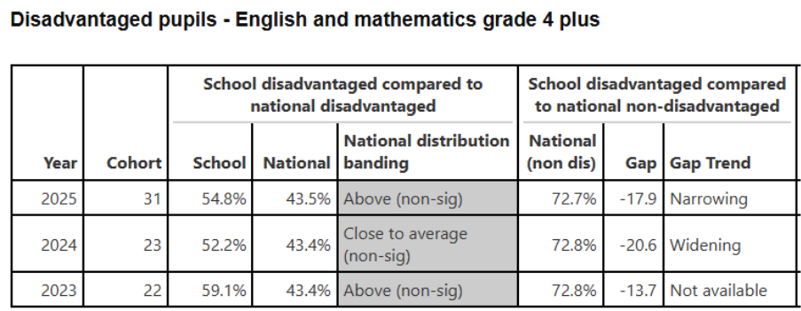
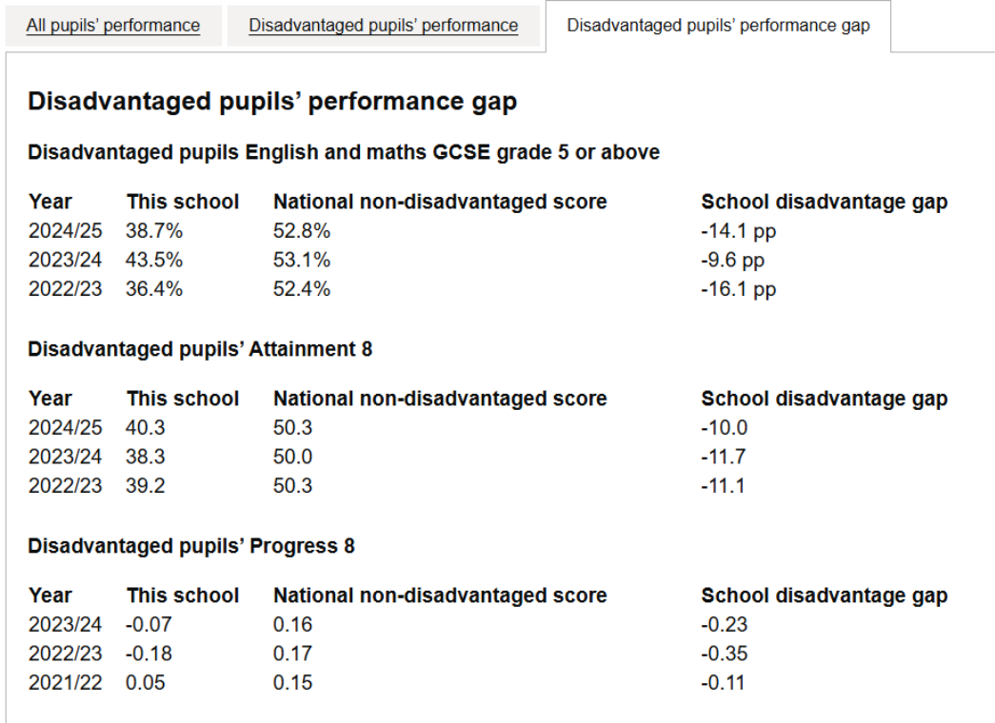

Objective - Reduce the gap in progress at Key Stage 4 between PP and non-PP students:

This has been partly successful. The A8 gap between PP and non-PP students is continuing to narrow. PP students performed broadly in line with the national average for all students in these cohorts. In 2025 the A8 score for disadvantaged pupils was 40.3, which is above the PP national average of 34.9, but with a -10, narrowing gap between PP and non-PP (source: gov.uk). However when comparing the disadvantaged cohort with their non-disadvantaged peers within school there is a 12.9% gap in A8.

Percentage scores for English and Maths 4+ and 5+ are significantly higher than the national averages for PP students with the gap of English and Maths at 4+ narrowing when comparing the disadvantaged cohort to the national non-disadvantaged (-17.9 compared to 20.6% in 2024). However the 5+ gap has widened by 4.5% (-14.1 compared to 9.6% in 2024). Again, there is a gap between the school disadvantaged and their no-disadvantaged peers.

These figures have been earned through many factors:
- Quality First Teaching by strong, experienced departments
- GCSE PP students were specifically targeted for a Citizenship Intervention Boost Programme, delivered in collaboration with the Head of Department, to reinforce cross-curricular skills and engagement
English - disadvantaged students are significantly above national disadvantaged in 4+ and 5+ and the gap is narrowing between them and national non-disadvantaged for 4+, but widening for 5+ which is a renewed focus for this academic year.
- Targeted interventions which prioritised PP and SEND students;
-29 PP students were involved in the Walk and Talk Mocks in year 11 – 3 2 hour targeted sessions which guided the pupils through the exam papers for English Language and English Literature
-15 PP students in Year 11 regularly attended Boost sessions for English
- Department data analysis after each assessment focuses on PP progress, analysing the distance from target to enable monitoring and discussion
- Smaller lower band groups in KS4 (of 20-22 pupils) for more targeted support
- CGP revision guides given to PP students as well as past paper booklets which include knowledge organisers / placemats for more structured revision
- All year 7 groups now have a timetabled library lesson to encourage them to visit the library at least 3 times per half-term and regularly loan books / receive book recommendations

Maths – disadvantaged students are significantly above national disadvantaged in 4+ and 5+ and the gap is narrowing between them and national non-disadvantaged.
- Having smaller groups at lower ability to better target those who need support
- Regular PP book scrutinies.
- Use of tutoring and BOOST to target PP students not making progress.
- An alternative way of setting Year 7 students so that they are placed in broader ability bands rather than strict sets.
- Printed Knowledge Organisers issued to PP students
- Revision guides and calculators purchased for PP students to close the disadvantage gap
- Regular communication with parents of students who are not making sufficient progress
- Ensuring that PP students who are borderline between two ability groups are placed in a higher group to sufficiently challenge them
Science - disadvantaged students are above national disadvantaged in 4+ and 5+ and the gap is narrowing between them and national non-disadvantaged for 5+, but not for 4+ where the gap is widening.

- Bespoke revision resources were provided to PP students in Years 10 and 11, tailored to individual learning needs and exam specifications
- Many PP students are placed in smaller Science classes with dedicated TA support, allowing for increased teacher interaction and personalised guidance
- GCSE PP students were specifically targeted for a Citizenship Intervention Boost Programme, delivered in collaboration with the Head of Department, to reinforce cross-curricular skills and engagement

Objective - T&L CPD

Teaching and learning is monitored through a QA process that includes department reviews, lesson observations, learning walks, drop ins, work scrutinies, and pupil voice. Outcomes of these are tracked and areas of need lead to both T&L Areas of Focus and CPD delivered. For example, the focus weeks in Autumn 2025 highlighted a lack of consistency within subject areas. Immediately, this became an additional area of focus for T&L for 2025-26 and CPD was delivered to MLT then, subsequently, to all teaching staff. Inset time was provided to ensure that content and knowledge delivered is consistent.
Additionally, teaching staff are allocated to a more personalised CPD programme according to need. In 2024-25 and 2025-26, staff attended training according to needs identified by the QA process, for example Questioning, Retrieval, Starts of Lessons, Behaviour Management, Whole Class Feedback.

Objective – Improving attendance
- We have not met the second objective of 95% attendance. Attendance to date for the disadvantaged cohort is 89.96% ranked by the DfE 8/43 schools locally and in the top 40-50% of schools. When compared to the non-disadvantaged cohort which has 95.9% attendance the Academy is placed 3rd/43 schools, illustrating the gap.
- Persistent Absence for disadvantaged students is 24.83%, 2/43 schools compared to 11.97% for non-disadvantaged placed at 2/43 schools locally.
- Severely Absent disadvantaged attendance is 5.6%, 14/43 schools compared to 0.8% for non-disadvantaged
This remains a focus for this year.

Objective - Students have a strong identity with their school and participate in activities in addition to the curriculum;
Our target to ensure that all PP students participate in an extra – curricular event be it a trip or team event to develop cultural capital was also largely successful with an improvement on 2023-24 figures with 90% of PP students engaging in some form of clubs, extra-curricular activities, trips and cultural experiences. We now have 86 extra curriculum activities to help foster belonging and sense of identity.

Six students were funded to attend the Summer School, although again this number is small and we are looking at how this can be increased further by advertising this differently to the primary schools. Five students were funded to complete work experience. There was an increased uptake of work experience this year with 16 of the 28 (62%) Year 10 students participating, but even with the offer of financial support not all took advantage of this offer. The reminders went to Wincanton Logistics Company for a day visit, Moulton College and also Tresham College. Leicester University and a company ‘Corporate Architecture came into school to deliver careers based sessions. Some of the disadvantaged cohort also visited the Innovation Centre for another day.

Targeted interventions to meet the specific needs of disadvantaged students with SEND;

This has been a moderate success. With the new SENDCo in post, targeted interventions have hugely increased. Interventions are now taking place in morning registration and during the day. These are run predominantly by TA’s, under the guidance of the SENDCo and Support Manager, who also do some. There are literacy and numeracy interventions along with social and emotional (Zones of Regulation/Friendship groups), which are facilitated by the ELSA. There has been an increase from 4 to 16 interventions this academic year, including external interventions to meet the rise in SEMH needs.
Intervention progress overall is good (‘As expected’) and we recognise the main challenge we need to overcome, non-attendance to all sessions for a variety of reasons.

Objective - Students will have the skills, resilience and support to manage their mental health and well-being.

This area is a significant strength and there are now many more provisions embedded for the increase in mental health needs. There are individual interventions, but the majority are group sessions which mean more students can be targeted and has value for money. Bloom is delivered in-house by our own Pastoral Managers, Zones of Regulation by the ELSA, and we have secured a range of external interventions through Teen Health, Mind and Relate. Eight students from the PP cohort had counselling sourced from the local charity The Cube - this is so we can meet the need and increase provision. Twenty disadvantaged students have been seen this year by counsellors, and this need is again observed as significantly higher than for non-disadvantaged. There is a well-being drop-in and a well-established Well-being mentor group who provide a lunch club for their peers, which is disproportionally attended by disadvantaged students, as is the LGBTQI+ group. There are also identified (by specific lanyard) staff allies who students can speak to.
Pastoral support is recognized as a strength of the Academy by Ofsted, who also cited that we have created a culture of safeguarding. This is evidenced by student voice in the annual ‘Sexual Harassment and Violence’ survey where, 95% of students indicate they feel safe and would tell a member of staff if something happened to them or another student.
The hygiene bag was taken up by 14 PP students, indicating the need to continue this next year, particularly with the increase in number of those seeking financial assistance due to the cost-of-living increases.

Objective - Careers and NEETS
This has been partially successful as all students in years 10 and 11 have been seen by the careers advisor and year 11 disadvantaged have all been helped with their post 16 application and have applied to at least one higher education establishment. Key stage 4 students have had both a mini careers fair and our large biannual careers fair where they have been exposed to several potential employees and post-16 providers. Year 9 and 11 have both had mock interviews with members of the public and completion of personal statements and ‘job’ applications, in preparation for the next stage of their journey. Work experience has increased to 62% of disadvantaged accessing it and impact is shown by the Gatsby Benchmarks/Matrix reaccreditation which scored the Benchmarks as;
1 100%, 2 73%, 3 68%, 4 79%, 5 88%, 6 80%, 7 84% and 8 100%.
Less successfully our records show that two students became NEET and both were disadvantaged. More support will be put in place for this next academic year to ensure it doesn’t happen again.

Interventions / Action | Impact | Action for 2025-26
The academy will maintain / increase the successful progress and attainment outcomes in our exam years whilst ensuring there is little or no variation between key learner groups in our year groups. | The A8 gap between our disadvantaged and non-disadvantaged national peers is narrowing and so is 4+ for English and Maths which shows that this was an effective strategy, however the gap for 5+ is widening. There is still a variation between disadvantaged students and their non-disadvantaged peers.  Therefore as teaching and learning has the most significant impact in closing the gap this year’s CPD focuses on inclusive strategies, metacognition, explicit instruction and retrieval. | - Continue to focus on strategies for inclusive teaching within the classroom HQFT teaching.
Excellent attendance of Disadvantaged and SEND students which supports their learning and ensures they can access the required support and protective factors. | Significant input by the pastoral team who weekly mentored all students who were PA.  Increase in capacity from 2 to 3 support managers.  Home visits carried out for PA and anyone missing 3 days of school without just cause.  Comprehensive support for non-attenders.  The PA for disadvantaged improved 4.31% to 26.15%.  Overall the attendance was 89.52% for disadvantaged which was significantly less than non-disadvantaged peers. | Continue to support
Improvement in literacy/reading skills. | The NGRT testing was not rolled out in a timely manner, therefore literacy interventions were delayed.  Literacy interventions have increased. | Continue to budget.  - New test (Hachette) to be used from this year in both literacy and numeracy.  - Interventions to be implemented earlier for maximum impact.
Staff continue to deliver QFT (and therefore raise aspirations of PP) through targeted, high quality CPD linked to appraisal/Strategic plan where possible. | Training delivered by Assistant Principal at the start of year on teaching and learning priorities.  Evidence from learning walks, observations and book scrutinies during focus weeks and throughout the year show that the focus for the year on cold calling and retrieval was evident.  Outcomes for all students was strong. | Continue to budget for these.  CPD budget focus on adaptive teaching and retrieval.
Students have a strong identity with their school and participate in activities in addition to the curriculum to represent the school or enhance their own knowledge / learning. | Student passport scheme embedded in year 7 and 8 with better uptake.  An increase in trips/extra-curricular activities offered to disadvantaged students.  Established student leadership team who have increased profile around school, have helped interview for new staff, have rewritten the well-being policy and who represent the Academy at events. | Continue to budget for this.
Students will have the skills, resilience and support to manage their mental health and well-being. | Schemes of work showing PSHE, RSE, or well-being topics (e.g., coping strategies, emotional regulation, mindfulness) in line with local area challenges and national statutory content.  Completion of resilience or mental health workshops. Well-being mentor training/increase of profile, PP specific mental health day, increased Teen health group workshops/ Zones of regulation/ELSA and counsellor support.  Trauma Informed Audit/recognition.  Staff training, bereavement, self-harm and EBSA. | Continue to budget for this and further support by increasing external support for mental health and well-being.

Externally provided programmes
Please include the names of any non-DfE programmes that you purchased in the previous academic year. This will help the Department for Education identify which ones are popular in England

Programme | Provider
Character development / Mental health support (Year 9) | Future Ready
Careers Fair | A number of external agencies
Alternative Provision | Invent, Brolay Farm, First Class Solutions - tutoring
Provision Map | Edukey

