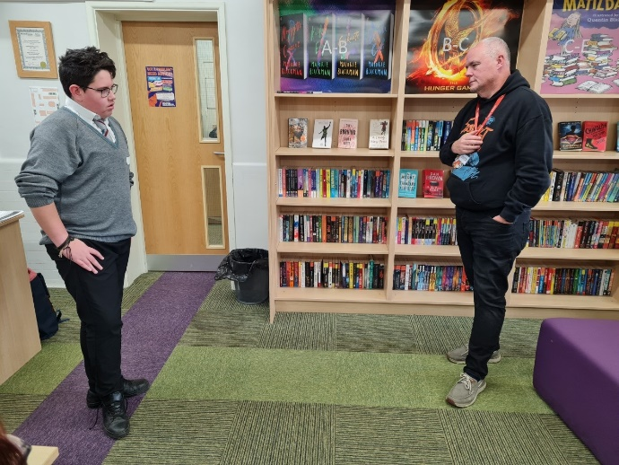
Learning for life
Welland Park academy facilitated safeTALK training for Year 11 students at the school. This international course empowers young people to identify practical steps to offer immediate help to someone with suicidal thoughts and move forward to connect with more specialised support.
A selected group of students attended the session and were grateful for the opportunity.
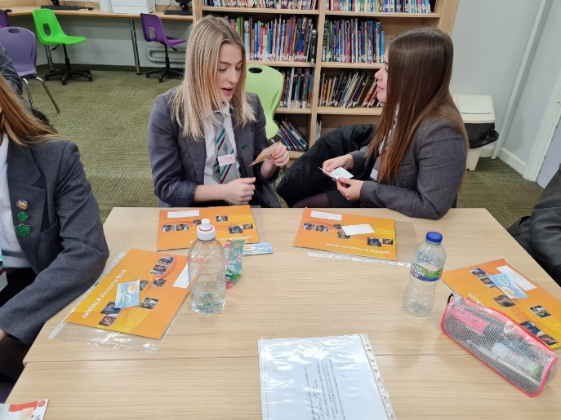
Jack, 16, said ‘I feel fully prepared to help someone if I ever need to’
Alan Savill, a former police officer, leads training nationally on strategies to prevent suicide. Earlier this year, Alan, the founder of the charity Ian’s Chain, delivered Applied Suicide Intervention Skills Training, (ASIST) to a group of Welland Park Academy staff and the Wellbeing Governor. He is passionate about widening the net of suicide alert people to ensure that thoughts of suicide are not dismissed, missed or avoided, and led the Year 11 training.
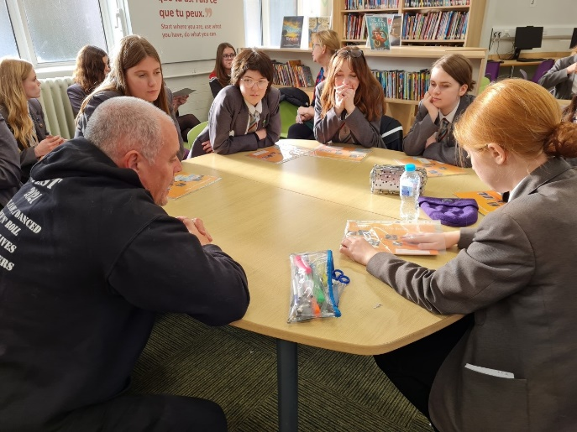
Alan worked with a co facilitator Jo Lovell, to teach the students about signposting to specialists for support, consider scenarios and role play conversations. He commented ‘this group of students were incredibly mature and insightful in considering different vulnerabilities and marginalised groups within society. We both thought they were so insightful, compassionate, caring and open. It is, in my experience rare to have such a group who supported each other, listened to each other and really want to make a difference.
Principal, Julie McBrearty commented, ‘ We welcome Alan’s expertise and appreciate the work of our incredible pastoral and teaching staff working with students to develop strategies to look after and support each other as part of wellbeing and promoting better mental health.’ The Principal additionally thanked the Market Harborough and Bowden’s charity for a grant to support this pioneering work.
‘This charity of modest, hard-working individuals supports our young people locally at an individual and cohort level. They do not always see the impact of the work their funding assists but it is far reaching! This training will give the youngsters life skills to support others. The school motto is Learning for Life and supporting good mental health and wellbeing is key!’

