POSITIVE BEHAVIOUR POLICY

Reference this policy is aligned to with LCC | n/a
Agreed with Support Staff Trade Unions | n/a
Adopted by the Governing Body | Sep 2022 (updated Jan 24)
Next Review Due | Sep 2024
Agreed with Teacher Trade Unions and Professional Associations | n/a

Aims

Welland Park Academy is fully committed to providing the highest quality education for each individual student, regardless of age, ability, gender or ethnic background. It expects high standards of achievement and behaviour in a positive, caring environment in which there exists a mutual respect between students, staff and parents.

This policy has been written in conjunction with the schools Equality and Diversity policy (Equality Act 2010), Exclusion from maintained schools, Academies and Pupil Referral Units in England (2012) and Behaviour and Discipline in schools (DfE guidance February 2014).

Principles

Welland Park Academy believes that, in order to enable effective teaching and learning to take place, good behaviour in all aspects of school life is necessary. It seeks to create a caring, learning environment by:-

- Positively promoting good behaviour and discipline
- Promoting self-esteem, self-discipline, appropriate regard for authority and positive relationships based on mutual respect
- Ensuring fairness of treatment for all
- Encouraging consistency of response to both positive and negative behaviour
- Promoting early intervention for students demonstrating challenging behaviour
- Providing a safe environment free from disruption, violence, bullying and any form of harassment
- Encouraging a positive relationship with parents and carers to develop a shared approach to the implementation of the Academy’s policy and associated procedures
- Ensuring that reasonable adjustments are applied on a case by case basis for students with physical or mental disabilities and SEND through collaboration of the Pastoral and SEND departments

Roles & Responsibilities

The Governing Body fully supports the Academy in maintaining high standards of behaviour. In consultation with the Principal, staff and parents, they have established this policy for the promotion of good behaviour throughout all aspects of Academy life. They will ensure that it is communicated to students and parents, is non-discriminatory and that its expectations are clear.

The Principal is responsible for the implementation of the policy and procedures and, with other members of the Senior Leadership Team, will organise support for implementing the policy.

Staff, including teachers, support staff, and volunteers, will be responsible for ensuring that the policy and procedures are followed consistently and fairly applied. At Welland Park Academy we recognise that mutual support amongst all staff in the implementation of the policy is essential. Staff have a key role in advising the Principal on the effectiveness of the policy, for creating a high quality learning environment and modelling the high standards of behaviour and punctuality expected from students.

Parents and carers will be expected to take responsibility for the attendance and behaviour of their child, both inside and outside the Academy. We believe it is vital that they work in partnership with the Academy to assist in maintaining high standards of behaviour and are encouraged to raise with the Academy any issues arising from the operation of the policy.

Students will be expected to take responsibility for their own behaviour and will be made fully aware of the Academy policy, procedure and expectations. Students also have a responsibility to ensure that incidents of disruption, violence, bullying and any form of harassment are reported.

Student guidance & support

At Welland Park Academy we acknowledge that there are some vulnerable students who need extra support to help them manage their behaviour and attendance. As such, we as an Academy are fully committed to collaborate with parents and external providers to ensure appropriate support and work to pre-empt escalating behaviour problems, truancy and unauthorised absence.

Strategies for behaviour support

- Clear expectations outlined in the Welland Park Agreement which is signed by student, parent, and tutor.
- Continuity of Form Tutor where possible
- Early identification of problems by subject leader/form tutor
- Working in partnership with parents
- Student Support Plans where appropriate
- Monitoring reports for behaviour, homework etc
- Mentoring with key members of staff
- Collaborative work with the SEND Department - Short intervention courses to address issues ie. Emotional literacy/social-communication skills
- Referral to specialist advice and support agencies – Educational Psychology Service, School Nurse, etc.
- Alternative provision/programmes
- Re-integration programmes
- Peer mentors
- Staff training
- Reasonable adjustments to behaviour systems made on a case by case basis
- Student passport and individual provision map for SEND students
- Behaviour Panel with Senior Leaders (Governors if appropriate)
- Opportunities for reflection and restorative conversations in the Behaviour Room

Rewards

Welland Park Academy promotes a positive culture of encouragement and achievement. We believe that rewards are much more effective than punishment in motivating students and in helping them to realise that their good behaviour and achievements are valued.

Students are frequently rewarded for their efforts on an informal basis through praise, written and verbal feedback about their work and behaviour. A more formal recognition is provided through our Reward System which is linked to the achievement system.

Reward/achievement points are to be awarded on the following scale.
A1 = 1 point
A2 = 2 points
A3 = 3 points
PRINCIPALS REWARD = 8 points
Similarly, points are accrued on an individual basis according to the severity of the misdemeanour i.e. C1 = 1 behaviour point, C2 = 2 behaviour points plus a brief detention, a removal from a lesson will be 3 minus points etc.
The Academy’s expectations are clearly explained both in the classroom via displays and the publications related to Behaviour, Uniform and Attendance.
Students may, for example, gain achievement points for
· Outstanding achievement in lessons
· Repeatedly demonstrating high standards of effort and commitment in your work, demonstrating use of our words associated with resilience values.
· Exceptional behaviour in lessons
· Regular participation in Academy teams or events
· Individual achievements outside of school i.e. Swimming / Charity Runs / Music Exams
· Taking part in extra-curricular activities
or have behaviour/consequence points added in cases similar to the examples below.
· Not meeting expectations in lessons, break or lunch times.
· Lack of effort with work.
· Late arrivals to site or lessons.
· Inappropriate uniform.
· Lack of appropriate equipment i.e. Pen, Pencil, PE Kit.
Achievement in the classroom is also recognised and celebrated through our rewards letters and achievement boards which highlight the top 20 students for each of the following areas:

- Most academic progress
- Working the closest to challenging academic targets
- Showing the highest commitment to learning

End of Year Trips
We offer rewards trips in the Summer Term to students who have successfully met the published behaviour criteria, with due consideration of medical information and reasonable adjustments.

Year 11 Prom
Participation in this event can be affected by behaviour. Reasonable adjustments will be considered.

Platinum Students
Platinum status is achieved by students who do not receive any C points during a term and are the top 10 students with the highest number of achievement points. Platinum students receive an additional reward of a fast pass to the Dining Hall.

Non – uniform day at the end of a half term.
The criterion for this reward is gold status. Students must not exceed a predetermined threshold of behaviour points in the preceding weeks and is clearly communicated to students and families. The number of behaviour points for the threshold is revised on a half termly basis.

Expectations

At Welland Park Academy we use the following opportunities to promote good behaviour and make clear our expectations:-
- Assemblies
- PSHE / Citizenship
- Welland Park Agreement
- Student Council
- Newsletters
- Communication with home via letter, postcard or email
- Academy Prospectus
- Achievement board
- School Facebook page
- Staff modelling our expectations through lessons, form time and extra-curricular activity

The Academy’s expectations are set out in the Student Code of Conduct/Welland Park Agreement. The set of non-negotiable expectations is shown below:
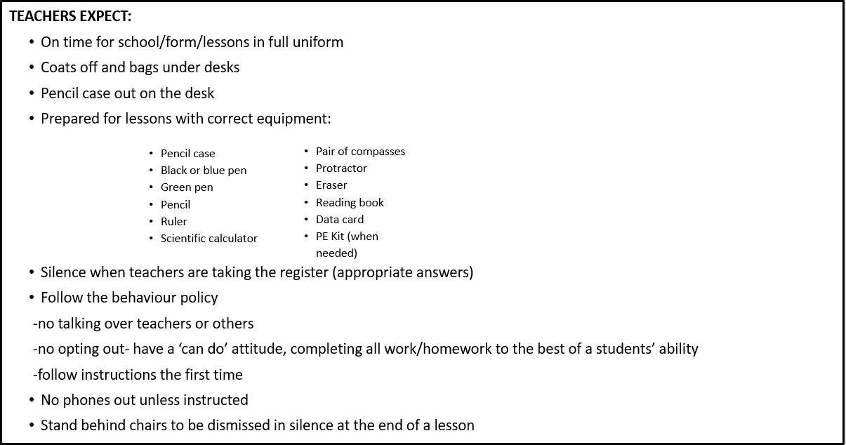

Expectations of students outside of lessons

Walking around the building
In an orderly fashion and where possible, students should walk on the left at all times and be aware of points of congestion. Staff monitor these areas at change-over times. Doors which are identified as ‘staff only’ should not be used by students and out of bounds areas should remain clear of students. Students are expected to wear the correct uniform appropriately at all times – this includes items of jewellery.

At break
A break service is available in the dining hall and when the weather is fine all students must either eat their snacks in the dining hall or leave the building. Eating is only allowed in the designated areas where the picnic tables are set out, where more litter bins are provided.

In wet weather two bells will indicate that students can also make their way to their year groups designated area. Students are not allowed to leave the school site at break. In inclement students may not be allowed outside if it is considered too unsafe.

At lunchtime
Lunch is served on a cafeteria system and students may also bring a packed lunch. Students are not allowed to leave the school site at lunch time. Certain areas of the school are closed to students at lunch time unless the students are directly supervised by a member of staff. Students must respond positively to lunchtime staff who are responsible for supervision during the lunch break and liaise closely with the member of staff on duty. Students who do not display suitable conduct at lunchtime will be requested to spend their lunchtime in a supervised room. Where there are repeated incidents of a student displaying unacceptable behaviour, parents may be asked to make alternative lunch time arrangements for a fixed period.

In wet weather two bells will indicate that students can either make their way to their designated area or stay in form rooms supervised by their period 4 teacher. Students are not allowed to leave the school site at break. In inclement weather students may not be allowed outside if it is considered too unsafe.

To and from school
Students are expected to behave sensibly on the journey to and from school, being considerate towards other students and showing respect towards members of the public. Students can expect sanctions to be applied if their behaviour outside school is below that expected in school and brings our school into disrepute.

Lateness – refer to the Academy’s Student Attendance Policy

On trips and visits
The highest standards of behaviour are expected from students making educational visits. Students must remember that they are representing the school and not do anything to risk the safety of students or staff or to damage the reputation of Welland Park Academy.

Food and Drink
In line with our Healthy School status, energy drinks are not permitted on site. Additionally chewing gum is not permitted in school.

The Pastoral team

When a student’s behaviour starts to give cause for concern, a personalised Support Plan will be put into place. This is led by the relevant Student Support Manager.

At all times, Welland Park Academy is committed to finding appropriate alternatives to fixed term suspensions and operates an internal alternative provision.

The Behaviour Room serves as an alternative to fixed term suspension and as a base for intensive and targeted support. This can be offered to those who require more specialist input helping them to adopt a solution focused approach. Restorative work may also be undertaken. Some students may access internal behaviour support and receive targeted bespoke interventions to make sustained and effective changes to their behaviours.

Bullying

*see the Anti-Bullying Policy for full details.

Bullying and conflict resolution often get confused. One off incidents where groups of children temporarily fall out with each other is not the same as bullying. The school will investigate alleged incidents in a firm and fair manner and use a variety of methods in dealing with anyone found to be bullying. Technology has allowed the possibilities of bullying via social media. These occurrences will be subject to the same sanctions as face to face bullying in school.

Racist / bi/homo/transphobic / sexist comments

Welland Park Academy is a multicultural, multifaith school and all forms of racist/bi/homo/transphobic/sexist behaviour is seen as unacceptable and will not be tolerated. Racist/bi/homo/transphobic comments and sanctions are treated as an extremely serious offence, home contact will be made and proportionate sanctions will be applied on a case by case basis. All comments of this nature made by students are logged.

Physical violence

Physical violence is an unacceptable form of behaviour. Students can expect sanctions if they involve themselves in this type of behaviour including fixed term suspensions or permanent exclusion.

Possession of drugs or offensive weapons

Offences of this nature will be dealt with most severely (see separate drugs policy) to include fixed term and/or permanent exclusion.

Dangerous objects will not be returned to students and in some cases the parents will be asked to collect the items, or in other cases, with the knowledge of the Principal, the police may be informed.

Possession of personal electronic devices eg: mobile, tablets etc.

Mobile phones are a distraction in lessons and are easy targets for theft. Lengthy investigations will not be undertaken as these consume time which can be better spent supporting student learning. Mobiles can be misused for bullying purposes, through sending messages or recording incidents that happen inside school. As such, students are discouraged from bringing them into school. If students are seen in possession of a phone, the phone will be confiscated and returned at the end of the day. In cases of repeated infringements, parents will be contacted and asked to collect the device. Devices can only be collected by adults with parental responsibility. If phones are brought into school, they must be switched off. The same applies to other electronic items including earphones.
Electronic items are not to be used on school site at any time without authorisation including before and after school.
Following a significant breach of this rule, students will be placed on a digital device agreement and required to hand their phone into reception.

Searching students & confiscation

Under powers laid down in the Education Act 2066 and following advice in the Searching, Screening and Confiscation advice for schools July 2022, staff may search a student if:
- They have the student’s consent – for any item
Without consent if they have reason to suspect that a student may have in their possession:
- Knives or other items that could be used as a weapon
- Alcohol
- Illegal drugs
- Stolen items
- Tobacco, cigarette papers, E-cigarettes, Vaporisers and other associated paraphernalia
- Fireworks
- Pornography
- Any article, including electronic devices, that a member of staff reasonably suspects has been, or is likely to be used
-to commit an offence
-to cause personal injury to, or damage to property of; any person (including the student)
- Any item which directly breeches the academy rules and/or safeguarding systems, including electronic devices and medication.
Such requests will usually be carried out with two members of staff present that are safeguarding trained, one of whom will be of the same gender as the student where possible. The exceptions to this rule are:
- If the member of staff carrying out the search reasonably believes there is risk that serious harm will be caused to a person if the search is not carried out as a matter of urgency AND
- In the time available, it is not reasonably practicable for the search to be carried out by a member of staff who is same sex as the pupil OR it is not reasonably practicable for the search to be carried out in the presence of another member of staff
A member of staff may search a student’s outer clothing, pockets, possessions, desks or lockers.
The authorised member of staff conducting the search will always seek the co-operation of the students before conducting a search. If a student is not willing to co-operate with the search, the member of staff will consider why this is. Reasons may include that they:
- Are in possession of a prohibited item
- Do not understand the instruction
- Are unaware of what a search may involve; or
- Have had a previous distressing experience of being searched
If a student continues to refuse to co-operate, the students will be sanctioned in line with this policy. The sanctions available include internal isolation and detentions, up to and including Suspension.
In high-risk situation, a dynamic risk assessment will be carried out to determine if reasonable force should be used to conduct the search for a prohibited item. This decision will be made on a case by case basis, considering if the search will prevent the student from hurting themselves or others, damaging property or causing disorder.
We will dispose of banned items that are not collected within a week.

Consequences and Behavioural Interventions

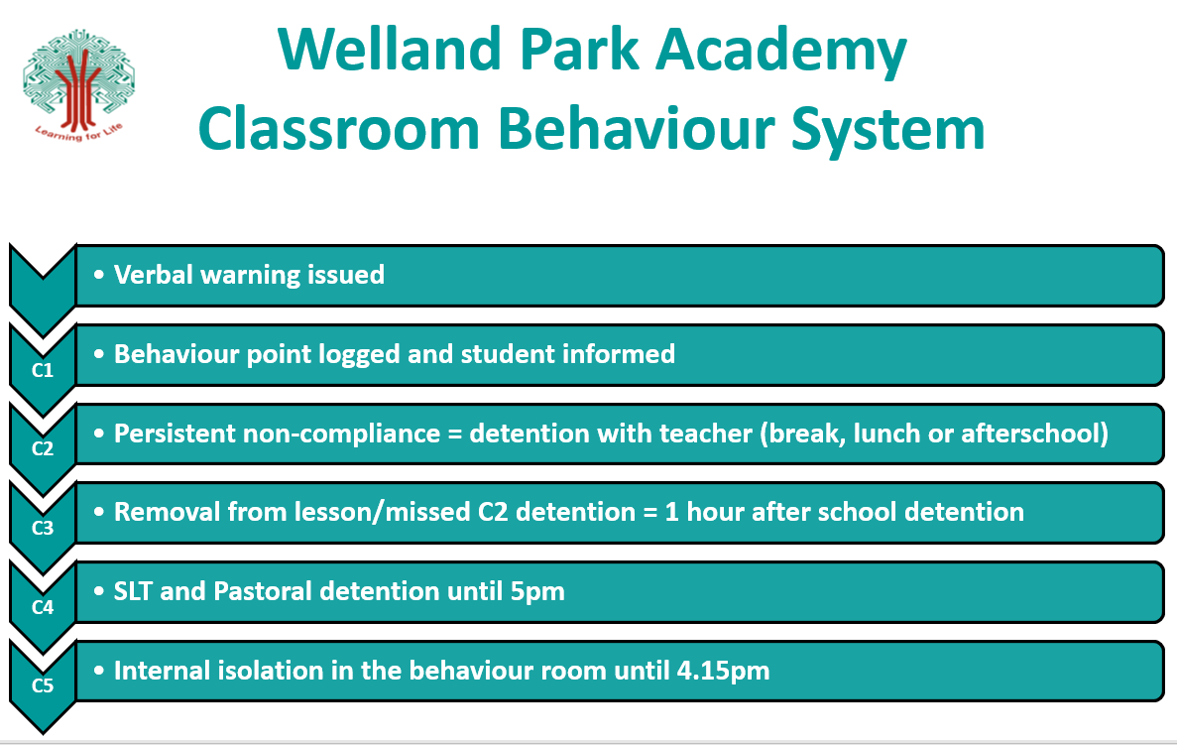
It is anticipated that many students will receive the occasional verbal warning during their time with us. Hopefully, as students mature and become more self-disciplined, the vast majority of student/teacher contact will be positive and enthusiastic.
The verbal warning, though not recorded, has two clear purposes:
- To indicate to student that they are doing something which is unacceptable and that they need to self-regulate.
- To indicate to students that their behaviour, if continued, will lead to the more formal recorded behaviour point behaviour system.
C1: if poor behaviour persists following the verbal warning, a formal C point will be recorded, and the student notified.
C2: as a result of continuing the behaviour which led to the initial verbal warning/C1, or for behaving in a way which is considered too serious to receive only a verbal warning/C1. This will be recorded by the member of staff and a short detention set, where a conversation can take place in order to prevent a reoccurrence of the issue.
Removal from a lesson: Occasionally students will continue to behave in an unsatisfactory manner despite receiving the verbal warning/C1/C2 and cause significant disruption to the learning of others. Such behaviour will result in the student being removed from the lesson to the supervised Behaviour Room. A member of staff will discuss the incident with the student whilst in the Behaviour Room, with a focus on reflecting upon actions. A detention will be set for the following day with the subject teacher to allow for missed work to be shared, and for a restorative conversation to take place. They will also lose their free time at break/lunch the following day.
A serious breach of behaviour may warrant immediate removal from a lesson.
Internal Isolation: This is a very serious sanction, sometimes used as an alternative to suspension. The Behaviour Room will have a functional and purposeful environment, with a bank of work to cover each curriculum area. The room is mostly supervised by members of the Pastoral team and the SLT. Students in the Behaviour Room will also be supervised for break/lunchtime and after school until 4.15pm. Students who successfully complete their time in the Behaviour Room are able to return to their regular classes at the end of the set period. High standards of conduct are expected in the Behaviour Room in order to complete the set period successfully.
There will be cases where behaviour points or removals are given without immediate prior warning where basic whole school expectations are not met.
Welland Park Academy has high expectations of students which are clearly outlined in the Positive Behaviour and Anti-Bullying Polices. If any student’s behaviour or work falls below these expectations it is important that staff take immediate, appropriate action. A range of sanctions are available to staff, who must judge each incident on its merit and then choose the appropriate one for the situation and the individual student. All incidents will be recorded on the Academy’s management information system (SIMS).

Staff will administer sanctions dependent on the transgression of our behaviour code. At Welland Park Academy we use a series of sanctions which include:

- Detentions at break, lunchtime or after school
- Removal of privileges such as access to the Internet, attendance on trips/prom
- Removal to the Behaviour Room
- Detentions until 5pm on Friday either for 8 behaviour points or serious transgressions
- Saturday morning detentions
- Alternative school arrangements such as working in the Behaviour Room from 1pm to 5pm of 8am to 12pm.
- Fixed term suspensions

Reporting System

SLT
Report
Student Support Manager Report
Progress Leader Report
Form Tutor Report

- Students will be placed on Form Tutor report for a period of two weeks in the first instance following the accrual of a set number of behaviour points in a term or at the discretion of the Progress Leader. This is in support of our ‘Going for Gold’ policy linked to the rewards system. We recognise that everyone makes mistakes, so students are given an ‘allowance’ of 1 C point per week
- If students have accessed each level of support without the desired outcomes being achieved, they will be placed on a Senior Leadership Team report

Reasonable Adjustment
“Under the Equality Act 2010 public sector organisations have to make changes in their approach or provision to ensure that services are accessible to disabled people as well as everybody else. Reasonable adjustments can mean alterations to buildings by providing lifts, wide doors, ramps and tactile signage, but may also mean changes to policies, procedures and staff training to ensure that services work equally well for people with learning disabilities” (www.gov.uk.2016)

At Welland Park Academy we recognise the differing needs of our students, and the requirement to apply personalised strategies in order to positively manage behaviour and relationships. We continually review our approach and adapt our strategies based upon regular evaluation of their impact in addition to input from specialist training. A non-exhaustive list of strategies that are in current use on a case by case basis after careful consideration of a specific situation can be seen below:

- Removal of detentions on a case by case basis
- Close liaison with parents/carers
- Adapted use of the reporting system
- Combining of sanctions
- Alternative accommodation for sanction
- Use of timeout cards/Take 5 cards
- Alternative curriculum provision
- Provision of uniform and equipment
- Traffic light systems for visual reminders
- Risk assessments and safety plans
- Customised uniforms
- Extended days and alternative timings
- Alternative to exclusion
- Breaks from homework
- Positive reports
- Home visits
- Collection of students in the morning to attend school
- Mentoring and 1:1 support
- Counselling by referral through Pastoral
- Aids for SEND – Learning aids/behaviour aids as per individual provision map (SEND)
- Small groups for anxiety, mindfulness, yoga, wellbeing, friendship, ‘Empower Her’, supporting autism in girls, breakfast club, AC access at break/lunchtime
- Headphone pass
- Targeted TA support on a case by case basis

Whilst recognising the differing needs of individual students, we also have a duty of care towards all of the students in the school. For this reason, there are rules which apply to every student to ensure that order is maintained both inside and outside the classroom, and that the health and safety of all students and staff are secured.

Whilst taking those reasonable adjustments into account, the minimum expectation is that all students follow the instructions of staff.

Fixed period suspensions

It is expected that the consequence system will be sufficient for dealing with the majority of incidents of poor behaviour. When this is deemed not to be the case the school reserves the right to issue more significant sanctions. These may include internal or external exclusions.

Fixed period suspensions are kept to a minimum and given in response to serious breaches of the behaviour policy, which include persistent disruptive or defiant behaviours.

It is the responsibility of parents to ensure that their child is not present in a public place in school hours during the first five days of any fixed period, or permanent exclusion from school. Parents could receive a fixed penalty notice if their child is found in a public place without justification. It can be expected that the Academy will provide, appropriate work to be completed at home via Edulink. Parents need to collect work if they cannot access the internet.

From the sixth day of any period of fixed period exclusion, it is the duty of the Academy to provide a full-time education for the student. Alternative arrangements will normally be made for students, such as attending a neighbouring school or a setting provided by the South Leicestershire Inclusion Partnership. For permanent exclusions, the Local Education Authority must arrange suitable, full-time education from day six.

The South Leicestershire Inclusion Partnership aims to provide alternative solutions to permanent exclusion. These alternatives may include a managed move to a partner school or a range of alternative academic provision.

Permanent Exclusions

Welland Park Academy adheres to a minimum permanent exclusion protocol. However, it is recognised that there are occasions when it may be necessary to permanently exclude, if allowing the student to remain in school would seriously harm the education or welfare of others in the academy or where there are serious and/or repeated breaches of the Academy’s behaviour policy. Only the Principal can exclude a student. The decision to exclude will only be taken where basic facts have been clearly established on the balance of probabilities.

Permanent exclusions will only take place when all other options have been exhausted. These shall include, but are not limited to:

- Input from the South Leicestershire Inclusion Partnership
- Consideration given to managed move arrangements
- Consideration given to an off-site arrangement
- And in the case of a student with an Education, Health, Care Plan of SEND - an emergency review.

There will, however, be exceptional circumstances where, in the Principal’s judgement, it is appropriate to permanently exclude a student for a first or ‘one off’ offence. These might include:

- Serious actual or threatened violence against another student or member of staff
- Sexual abuse, sexual harassment, use of indecent and highly inappropriate language, imagery or material (including electronic) and/or assault against another student or member of staff
- Supplying an illegal drug and incidents relating to illegal drugs
- Possession of an offensive weapon or object which could cause harm

Intervention and restraint of students

There may be rare occasions where it is necessary to physically restrain a student or physically intervene to prevent a significant risk of harm. These shall include:

- To prevent a student self-injuring
- To prevent a student injuring another person
- To prevent a student committing an offence
- To prevent a student damaging property
- To prevent a student engaging in any behaviour prejudicial to maintaining good order and discipline at school, whether that behaviour occurs during a teaching or non-teaching session or otherwise

A number of staff have received appropriate formal training for student restraint.

For information on student restraint please refer to the Physical Intervention/Restraint of Students Policy.

Attendance & punctuality

The Academy provides a challenging and supportive environment, which positively encourages all students to attend all sessions. We believe that good attendance is essential to educational success and place great emphasis on partnership with parents. We strive for a minimum of 96% attendance for our students. Please refer to the Academy’s Attendance Policy for detail.

Students who are late to school after 8.45am when the main gate closes, are issued with a C1 and lunchtime detention on the same day. Pastoral staff continually work with students to identify and remove barriers to their poor punctuality. If there are three occurrences of lateness to school, students will be placed in an SLT detention.

Policy review

The Assistant Principal (Inclusion), in consultation with the staff, will undertake systematic monitoring and regular reviews of this policy and procedures in order to evaluate their effectiveness.
The Principal will keep the Governing body informed.

Associated documents

Teaching and Learning Policy
Welland Park Agreement
Anti-Bullying Policy
Equality and Diversity Policy
Student Attendance Policy
Child Protection Policy
Physical intervention/restraint Policy
SEND Policy
SEND local offer

